

Sem 1 Examination 2015

Question/answer booklet
Name: ______________________________________
Teacher: ______________________________________

YEAR 10
ACM MATHEMATICS

Section Two: 50 Marks
Calculator-assumed

Time allowed for this section
Section One
Reading time before commencing work: 5 minutes
Working time for paper: 50 minutes

Material required/recommended for this paper

To be provided by the supervisor
This question/answer Booklet
Formula sheet

To be provided by the student
Standard items: pens, pencils, pencil sharpener, eraser, correction fluid/tape, ruler, highlighter

Special items: drawing instruments, templates, notes on one unfolded sheets of A4 paper (written on both sides), and scientific calculator

Important note to students

This test comprises of TWO sections. The first section is calculator free where no calculators of any kind are to be used. The second section is calculator assumed where a scientific calculator may be used. All questions must be answered in both sections. Answers should be rounded appropriately. All working should be shown in the space provided. Your working should be in sufficient detail to allow your answers to be checked readily and for marks to be awarded for reasoning. Incorrect answers given without supporting reasoning cannot be allocated any marks. For any question or part question worth more than two marks, valid working or justification is required to receive full marks.

No pen, pencils, highlights etc. may be used during reading time. This time is to be used to read through the assessment and check that you understand what is being asked of you. You may speak with the teacher/supervisor during this time (by putting up your hand and waiting patiently for them to approach you) but you may only ask clarification questions and not how to solve the problems. After reading time has ended, you may not ask any more questions.

8. | [4 Marks: 1, 1, 1, 1]
 | Calculate the values of the following
a) | 1 000 00$0^{\frac{2}{3}}$ | b) | 3^{1.9}, rounded to three decimal places.
c) | How many Litres are there in 4.9 kL? | d) | How many cm² are there in 0.0059 m²?
9. | [4 Marks: 2, 2]
5.3 cm | Use the prism below to answer the following questions  4 cm  6 cm  7 cm
a) | Find the Surface Area of the prism. | b) | Find the volume of the prism.

10. | [5 Marks: 3, 2]
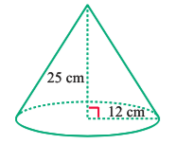
Use the prism below to answer the following questions.
Round your answer to two decimal places.

a) | Find the Surface Area of the prism. | b) | Find the volume of the prism.
11. | [2 Marks]
Find the capacity of the rectangular container

5 cm

7 cm

6 cm

12. | [3 Marks]
Find the exterior surface area of the following shapes.
Round your answer to 1 decimal place.
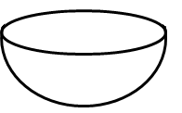
6.5 mm
Hint: this is a hemisphere

13. | [3 marks]
A company is asked to manufacture 150 000 solid steel cones each having a radius of 2 cm and perpendicular height of 10 cm.
Determine how many cubic metres of steel this will require.
14. | [3 Marks]
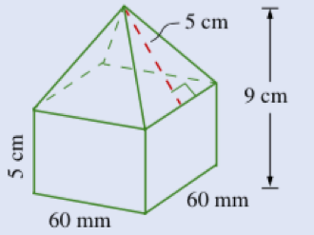
Calculate the volume of this composite shape:

15. | [4 Marks]
A solid cube with a surface area of 600 cm² has the same volume as a rectangular prism.
If the base of the rectangular prism has dimensions of 10 cm by 5 cm find the height of the prism.

16. |  | [6 Marks: 1, 2, 3]
a) | $\frac{4x}{3}+\frac{x}{3}$ |  | b) | $\frac{3d}{2}-\frac{d}{4}$
c) | $$\frac{4x}{x+1}+\frac{2}{x+2}$$

17. |  | [8 Marks: 1, 2, 2, 3]
a) | $\frac{x}{6}×\frac{9y}{4}$ |  | b) | $$\frac{3x}{5}÷\frac{x-2}{8}$$

c) | $$\frac{x^{2}-6x+5}{x-5}$$ |  | d) | $$\frac{x^{2}-8x+15}{x^{2}-3x-10}÷\frac{x^{2}-6x+9}{x^{2}+5x+6}$$
18. |  | [8 Marks: 1, 1, 2, 2, 2]
a) | $\frac{x}{3}=12$ |  | b) | $$-6x+5=17$$
c) | $$4x+12=6x-8$$ |  | d) | $$-4\left(3-4x\right)=-36$$
c) | $$\frac{5(x-4)}{3}+2=17$$

~ END OF SECTION TWO ~

